**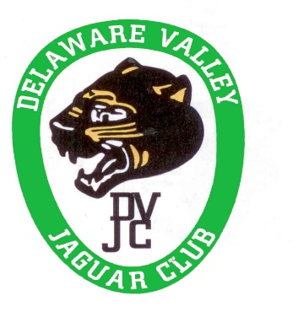*Please join us for our Annual Holiday Party and Awards Celebration.***

***Sunday, January 19, 2025***

***11:30 am to 3:30 pm***

*William Penn Inn*

*1017 DeKalb Pike*

*Ambler, PA 19002 (GPS address)*

*At the corner of Rt. 202 and Sumneytown Pike*

*11:30 a.m. Cocktail Hour –* ***Cash Bar*** *with Snacks*

*12:30 p.m. Buffet Brunch*

Buffet Brunch includes:

Hot and Cold Selections including:

Scrambled Eggs

Belgian Waffles

Beef Burgundy

Sweet and Sour Chicken

Shrimp Scampi

Salads

Delicious Deserts

and much more.

***There will be a Silent Auction of Jaguar Automobilia***

***and other automotive items.***

If you wish to contribute to the **Silent Auction** please contact:

Jim Sjoreen at jsoreen3860@Comcast.net  
Noe LaFramboise at jagnoe@att.net

The popular themed **Gift Basket Raffle** is also returning to the party.

Creative donations from our members are requested.

Please contact Sue Trout at [scarletsmt@aol.com](mailto:scarletsmt@aol.com)

if you wish to donate a basket.

**The cost for all of this is only $40 per person.**

**You must register for this event Prior to January 15, 2025**

**Register on the DVJC Website Here Now!**

Alternately, please send a note indicating the number of people attending with a check payable to Delaware Valley Jaguar Club by January 15, 2024 to:

Paul Trout 210 Warwick Furnace Rd Elverson, PA 19520

610-286-5701 or pgtgt@aol.com